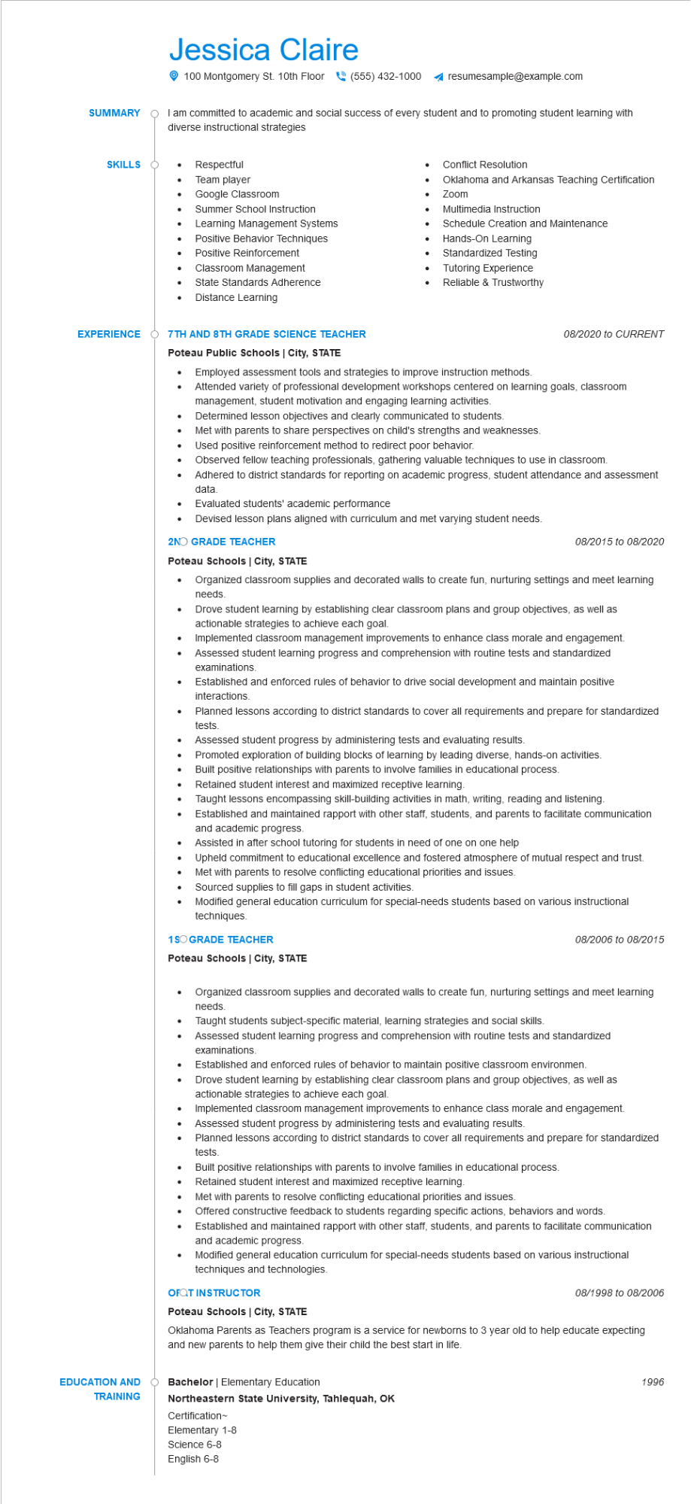
SUMMARY
Jessica Claire
100 Montgomery St. 10th Floor(555) 432-1000
resumesample@example.com
I am committed to academic and social success of every student and to promoting student learning with diverse instructional strategies
SKILLS O
•
•
Respectful
Team player
Google Classroom
• Summer School Instruction
•
Learning Management Systems
Positive Behavior Techniques
Positive Reinforcement
Classroom Management
• State Standards Adherence
Distance Learning
EXPERIENCE Ŏ7TH AND 8TH GRADE SCIENCE TEACHER
Poteau Public Schools | City, STATE
•
•
Conflict Resolution
•
•
Zoom
Oklahoma and Arkansas Teaching Certification
Multimedia Instruction
Schedule Creation and Maintenance
Standardized Testing
Tutoring Experience
Reliable & Trustworthy
•
Hands-On Learning
Employed assessment tools and strategies to improve instruction methods.
08/2020 to CURRENT
Attended variety of professional development workshops centered on learning goals, classroom
management, student motivation and engaging learning activities.
Determined lesson objectives and clearly communicated to students.
Met with parents to share perspectives on child's strengths and weaknesses.
•
Used positive reinforcement method to redirect poor behavior.
•
Observed fellow teaching professionals, gathering valuable techniques to use in classroom.
Adhered to district standards for reporting on academic progress, student attendance and assessment data.
•
Evaluated students' academic performance
Devised lesson plans aligned with curriculum and met varying student needs.
2NO GRADE TEACHER
Poteau Schools | City, STATE
•
•
•
•
•
•
08/2015 to 08/2020
Organized classroom supplies and decorated walls to create fun, nurturing settings and meet learning needs.
Drove student learning by establishing clear classroom plans and group objectives, as well as actionable strategies to achieve each goal.
Implemented classroom management improvements to enhance class morale and engagement. Assessed student learning progress and comprehension with routine tests and standardized examinations.
Established and enforced rules of behavior to drive social development and maintain positive interactions.
Planned lessons according to district standards to cover all requirements and prepare for standardized tests.
Assessed student progress by administering tests and evaluating results.
Promoted exploration of building blocks of learning by leading diverse, hands-on activities.
Built positive relationships with parents to involve families in educational process.
Retained student interest and maximized receptive learning.
Taught lessons encompassing skill-building activities in math, writing, reading and listening.
Established and maintained rapport with other staff, students, and parents to facilitate communication and academic progress.
Assisted in after school tutoring for students in need of one on one help
Upheld commitment to educational excellence and fostered atmosphere of mutual respect and trust.
Met with parents to resolve conflicting educational priorities and issues.
Sourced supplies to fill gaps in student activities.
Modified general education curriculum for special-needs students based on various instructional techniques.
1SO GRADE TEACHER
Poteau Schools | City, STATE
08/2006 to 08/2015
• Organized classroom supplies and decorated walls to create fun, nurturing settings and meet learning needs.
•
Taught students subject-specific material, learning strategies and social skills.
Assessed student learning progress and comprehension with routine tests and standardized examinations.
•
Established and enforced rules of behavior to maintain positive classroom environmen.
Drove student learning by establishing clear classroom plans and group objectives, as well as actionable strategies to achieve each goal.
•
Implemented classroom management improvements to enhance class morale and engagement. Assessed student progress by administering tests and evaluating results.
Planned lessons according to district standards to cover all requirements and prepare for standardized tests.
•
Built positive relationships with parents to involve families in educational process.
•
Retained student interest and maximized receptive learning.
Met with parents to resolve conflicting educational priorities and issues.
•
•
Offered constructive feedback to students regarding specific actions, behaviors and words.
Established and maintained rapport with other staff, students, and parents to facilitate communication and academic progress.
Modified general education curriculum for special-needs students based on various instructional techniques and technologies.
OFQT INSTRUCTOR
08/1998 to 08/2006
Poteau Schools | City, STATE
Oklahoma Parents as Teachers program is a service for newborns to 3 year old to help educate expecting and new parents to help them give their child the best start in life.
EDUCATION AND
Bachelor | Elementary Education
TRAINING
Northeastern State University, Tahlequah, OK
Certification~
Elementary 1-8
Science 6-8
English 6-8
1996

